THE LINEAR VELOCITY TRANSDUCER

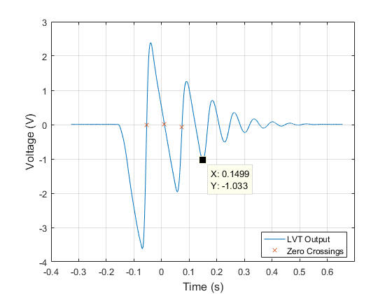

Figure 1: Plot of LVT measurement voltage vs. time

**The Motion Of Mass:**

During free fall, the slope of the velocity is linear, indicating there is a constant force acting on it in the negative direction – this is the force of gravity. The slope of the velocity measurements are negative, indicating by convention that the mass is falling. During initial impact with the foam, the velocity is still negative but begins to increase towards the positive direction, indicating the foam slows down the mass and slowly accelerates it at constant force (spring force) in the positive, upwards direction. When the velocity measurement crosses zero the first time at the leftmost labeled X point in Figure 1, the mass has reached the bottom of its trajectory inside the foam with maximum elastic potential energy and zero kinetic energy. Therefore, a short while after the X point the mass would bounce off the foam. At that moment, the mass would be travelling in the positive y direction and experience only experience the negative acceleration of gravity.

**The Physical significance of** the first three zero crossings are labeled by X in Figure 1. The first zero crossing is when the mass reached the lowest point inside the foam. The second zero crossing is when the mass reached the highest point after first bounce. The third zero crossing is when the mass reached the lowest point (with respect to each cycle) inside the foam. The first minimum voltage point is when the mass is about to hit the foam at a point where the gravitational potential energy is entirely converted to kinetic energy (maximum speed). The first maximum voltage point is when the mass reached the damped starting position where the undamped net displacement would be zero and velocity would be maximized.

**After three free falls**, the approximate time when the mass stopped bouncing off the foam is 0.15s. After that point, the negative displacement part of the velocity measurement appeared more like a second order damped output.

**Sensitivity of the Instrument:**

The MATLAB Polyfit linear regression function of the initial slope gives -47.251 V/s. With gravity, g = -386 in/sec2:

**Integrated Position and Velocity**

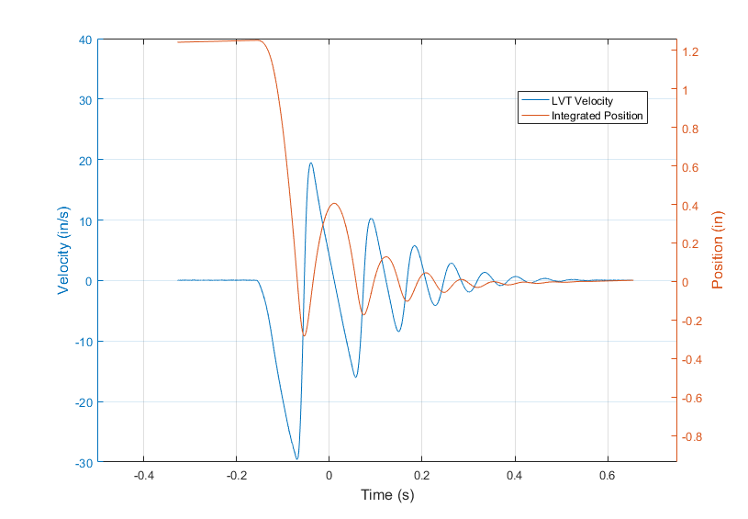

Figure 2: LVT measurement converted to velocity and integrated to give position

Figure 3, next page, shows the damped foam-mass system response. The circular peaks are used to determine the damping ratio and damped natural frequency. The spring constant is found using the equation: .

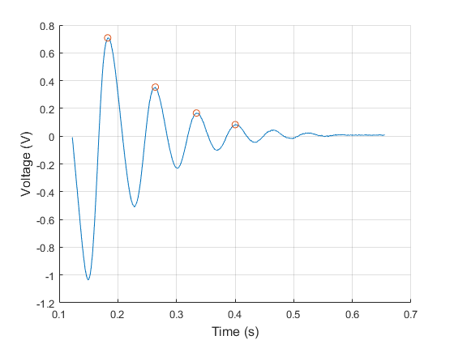

Figure 3: Damped portion of the foam-mass system

**Equations:**

**The average force of impact** when the shaft hits the foam would be equal to the damping force of the foam, which is relative to its damping coefficient:

Using damping force formula:

Where is the velocity of the mass upon impact with the foam, using the first three minimum peaks in Figure 1 (since the first three falls are estimated to be free falls):

Which gives an average force: